
March monthly report
……....................................
Dr. Pongkarn Chakthranont
Project:
Advancing Integrated Materials and Devices for Electrochemical CO₂ Reduction (AIM-COR)
Sothearoth Heng (ID: 803198)
Under the supervision of
Dr. Pongkarn Chakthranont
Contract Number: NCR-NN-2026-25421-EN
March 2026 report

- To-do list in March
  - Studies on electrochemical CO₂ reduction of sputtered silver catalyst with varied catalyst thickness (100, 300, and 500nm) under a pure CO₂ gas stream at 100 -200mA/cm² and elevated pressures (0 – 7 BarG)
  - Effect of Flow field configuration: Single vs Quad-serpentine
- Experimental Procedure
Synthesis of NiSAC by pyrolysis method
The synthesis of NiSAC catalyst was followed by our previous work. Initially, nickel phthalocyanine (NiPc), urea, and dicyanamide precursors were stoichiometrically weighed according to mass ratios of x:5:5, wherein urea and dicyanamide were maintained at 5 g each while varying the NiPc content (x = 0.25, 0.5, 1.0, and 2.0 g). Subsequently, the mixture was thoroughly mixed and ground until a homogeneous midnight blue powder was obtained. The fine powder was then transferred into a quartz boat covered with a capsule lid and subjected to polymerization at 800 °C (ramp rate = 10 °C·min⁻¹) in a horizontal tube furnace under an argon atmosphere (flow rate = 200 sccm) for 2 h. The as-prepared xNiSAC catalysts with different NiPc contents were finally obtained and labeled as 0.25NiSAC, 0.5NiSAC, 1.0NiSAC, and 2.0NiSAC.

Preparation of NiSAC cathode electrode via spray coating method
The NiSAC gas-diffusion electrode was fabricated by spray coating onto Sigracet 39BB carbon paper or hydrophilic carbon cloth substrates. Typically, 150 mg of as-prepared NiSAC and 381 μL of XC-2 ionomer were ultrasonically dispersed in 10 mL of isopropanol (IPA) for at least 1 h to form a homogeneous dark colloidal suspension. The ink suspension was subsequently spray-coated onto a 11 x 11 cm² carbon substrate using an automated, custom-built spraying setup equipped with a syringe pump operating at a flow rate of 0.6 mL min⁻¹ on a hotplate maintained at 130°C, yielding a catalyst mass loading of 1.8 ± 0.1 mg.cm⁻².
Note: a bottle of ink suspension containing 150mg of Ni-SAC catalyst yields only ~ 0.7 ± 0.1 mg.cm⁻².

Electrochemical measurements in membrane-electrode assembly (MEA) electrolyzer
100cm² MEA electrolyzer operational set-up
A 100 cm² MEA electrolyzer was used to evaluate the CO2RR performance under modulated operating conditions. The Ni foam or IrO₂-TiPt felt (10.5 x 10.5 cm²), bipolar membrane (BPM, 15.6 x 16.8 cm²), and 0.5Ni-SAC (10.5 x 10.5 cm²) were employed as the anode, membrane, and cathode electrode, respectively. The MEA was assembled with 0.25µm PTFE gasket and tightened at a compression force of 20 ft.lb. 10 L of 0.25 M KOH was recirculated and used throughout the experiment as the anolyte at 150 ml/min. The humidified CO₂ gas stream was introduced into the cathodic inlet with a total CO₂ flow rate of 200-1000 ml/min. Prior the test, the electrochemical impedance spectroscopy (EIS) and Cyclic voltammetry were measured. Meanwhile, the cathodic outlet was directly injected into an online gas-chromatography for gas products analysis.

- Results
Influence of Ag_{Sputtered} thickness on CO2RR performance under pure CO₂ at 100mAcm⁻², 35°C, and 0-5 BarG
To asertain the effect of the thickness of sputtered silver catalyst on CO2RR performance, we experimentally conducted the electrochemical CO2RR on sputtered silver catalyst with 100, 300, and 500nm thickness under a pure 200ml/min CO2 gas stream, cell temperature of 35C, and applied pressure range of 0 – 5 BarG. As shown in Figure 1, all the sputtered silver catalyst exhibited a very low FE(CO) of up to 20% with cell potential of 3.4 – 3.6 V under ambient pressure (0BarG) due to highly competetive HER activity in r-BPM system. Interestingly, by further increasing the applied pressure from 0BarG to 3BarG, the FE(CO) of 100 and 300nm sputtered silver catalyst is moderately increased, while 500nm sputtered silver catalyst showed a slight increase compared to ambient pressure. Further increasing the applied pressure to 5BarG, the CO2RR performance of both 100 and 300nm sputtered silver catalyst were further improved with a slighltly high cell voltage compared to lower applied pressures. This might be resulted from continuously operation since the ambient pressure up until higher pressures which leads to decreasing KOH anolyte concentration, thereby decreasing the overall system conductivity. Moreover, the long-term stability test of all sputtered silver catalysts demonstrated that 100 and 300nm sputtered silver sustained a similar FE(CO) > 43%, while 500nm sputtered silver catalyst achieved only 12% of FE(CO) under an elevated pressure of 5 BarG. It is worth noting that the KOH concentration plays a key role for improving both system conductivity and CO selectivity. The higher the KOH concentration the better the system conductivity and CO selectivity. After more than 25hr of operation in both 100 and 300nm sputtered silver, we observed a continuously decrease in FE(CO) from the initial operation which might be attributable to the dilution of KOH concentration over time. Therefore, to further improve the CO2RR performance and system conductivity, higher KOH concentration should be used, though there’s a trade-off between improving system efficiency and salt formation.

To evaluate the capability of the 100 cm² MEA to operate at higher applied current density, we conducted CO₂RR performance testing using a 300 nm sputtered silver catalyst under pure CO₂ at 35 °C and 5 barG at 200 mA cm⁻². It should be noted that this experiment was performed immediately after a 35 h long-term stability test at 100 mA cm⁻². Therefore, the system conductivity and CO selectivity may deviate from the actual performance of a freshly operated system. At 200 mA cm⁻², the system sustained a Faradaic efficiency for CO (FE(CO)) of only 12%, with an initial cell voltage of 4.15 V that increased to 4.5 V after 5 h of operation. Based on the pressure and voltage profiles, an abrupt increase in both pressure and voltage was observed after 3.5 h of operation, which was attributed to salt accumulation clogging the inlet gas flow. These results indicate that operation at 200 mA cm⁻² with a sputtered silver catalyst is feasible, although it requires a relatively high cell voltage.
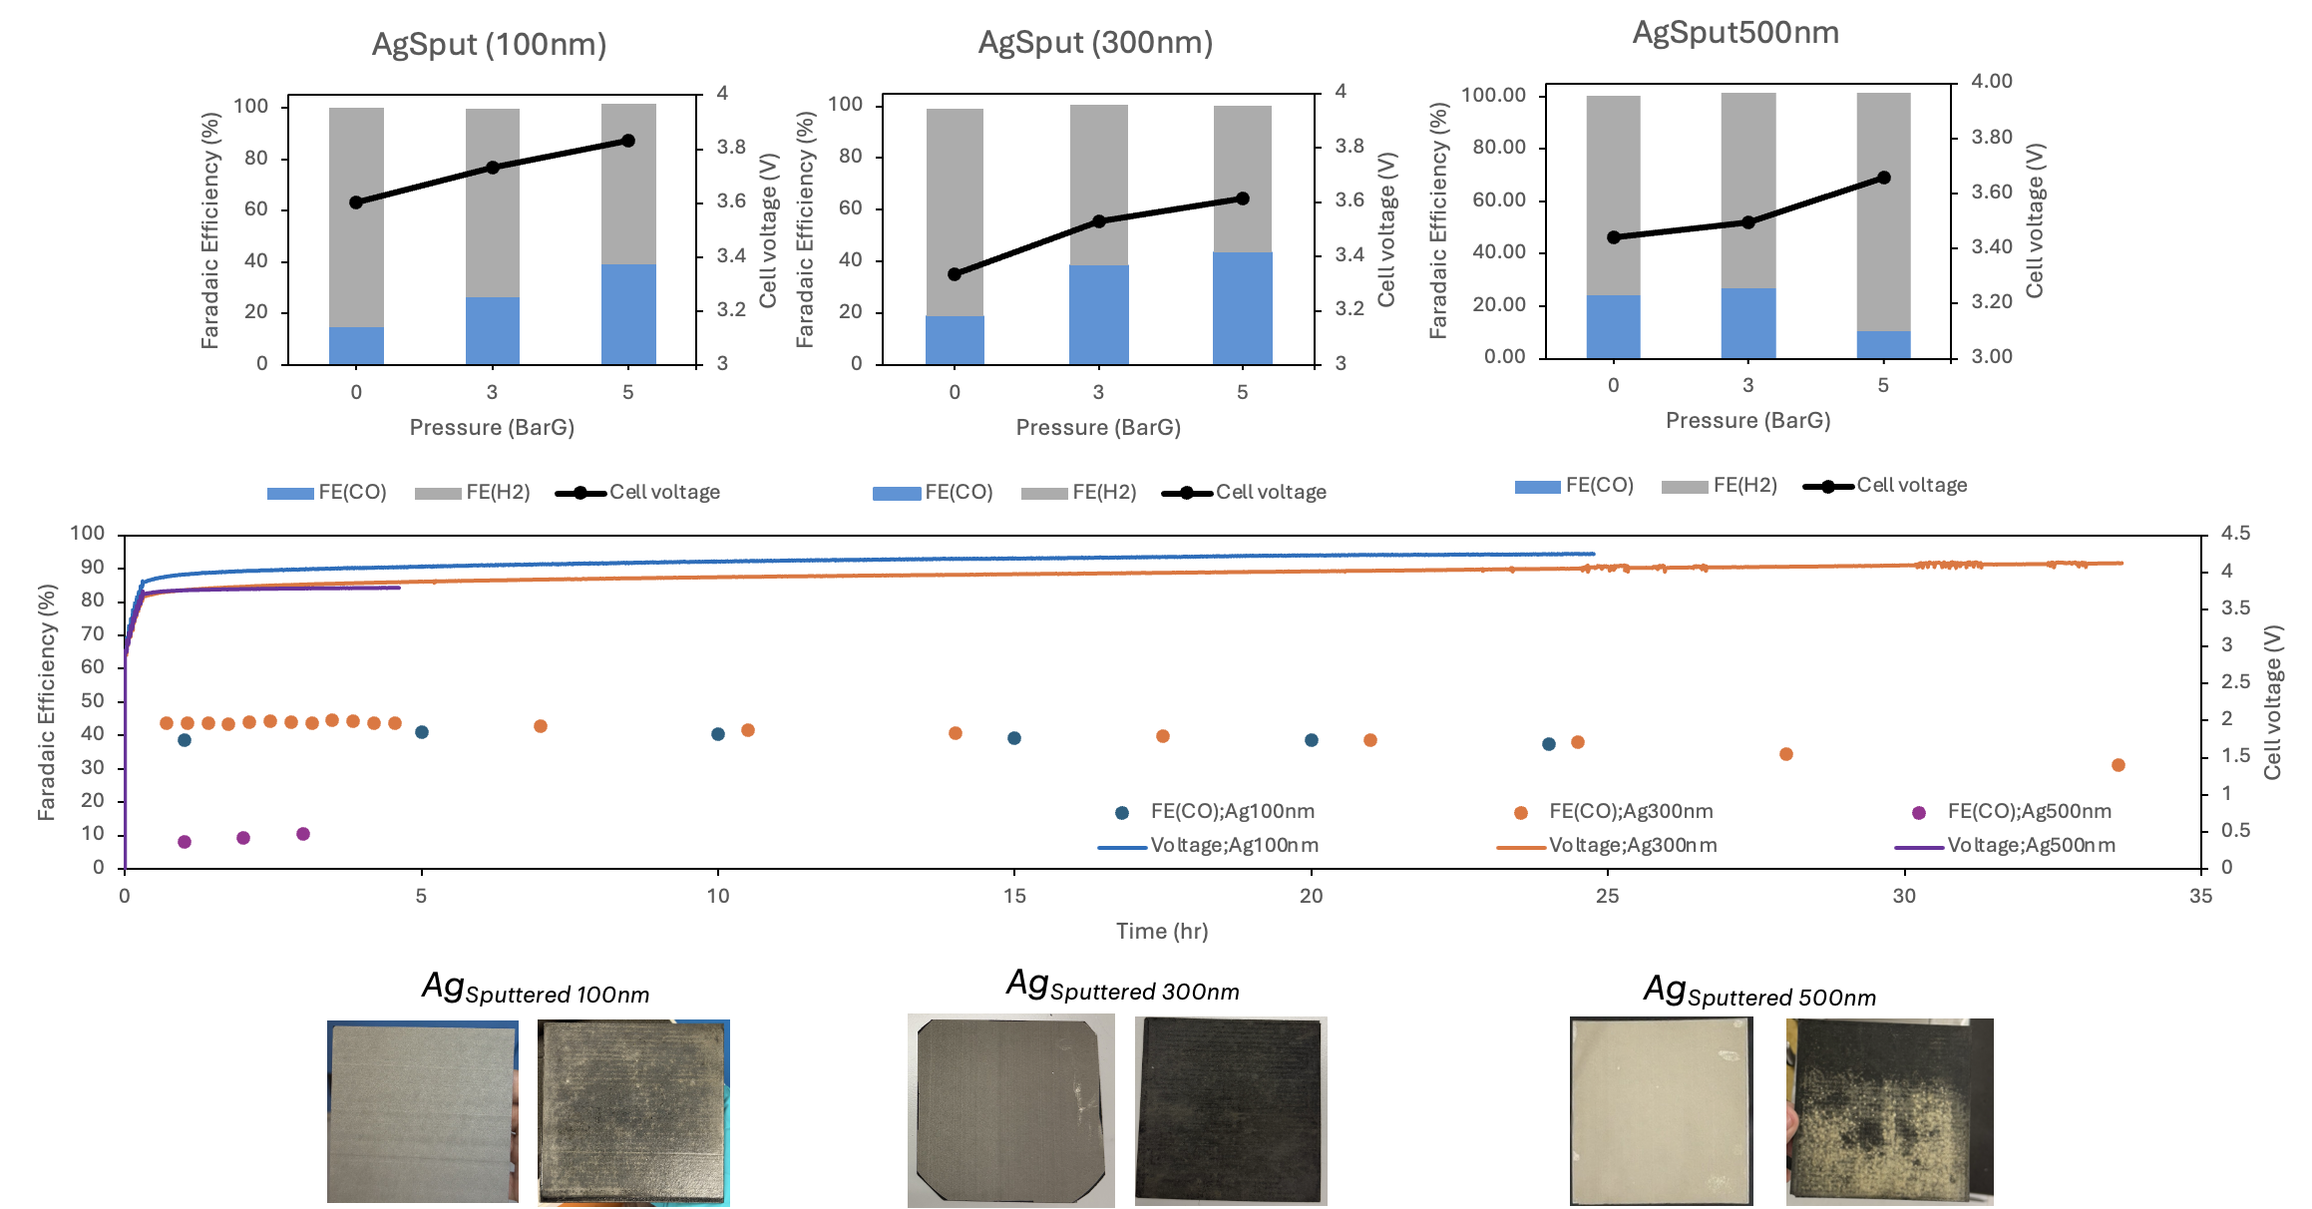
Figure 1. CO₂ electrolysis of Ag_{Sputtered} under 200ml/min CO₂, 150ml/min 0.25M KOH, 35°C, 0-5 BarG, and 100mA/cm²

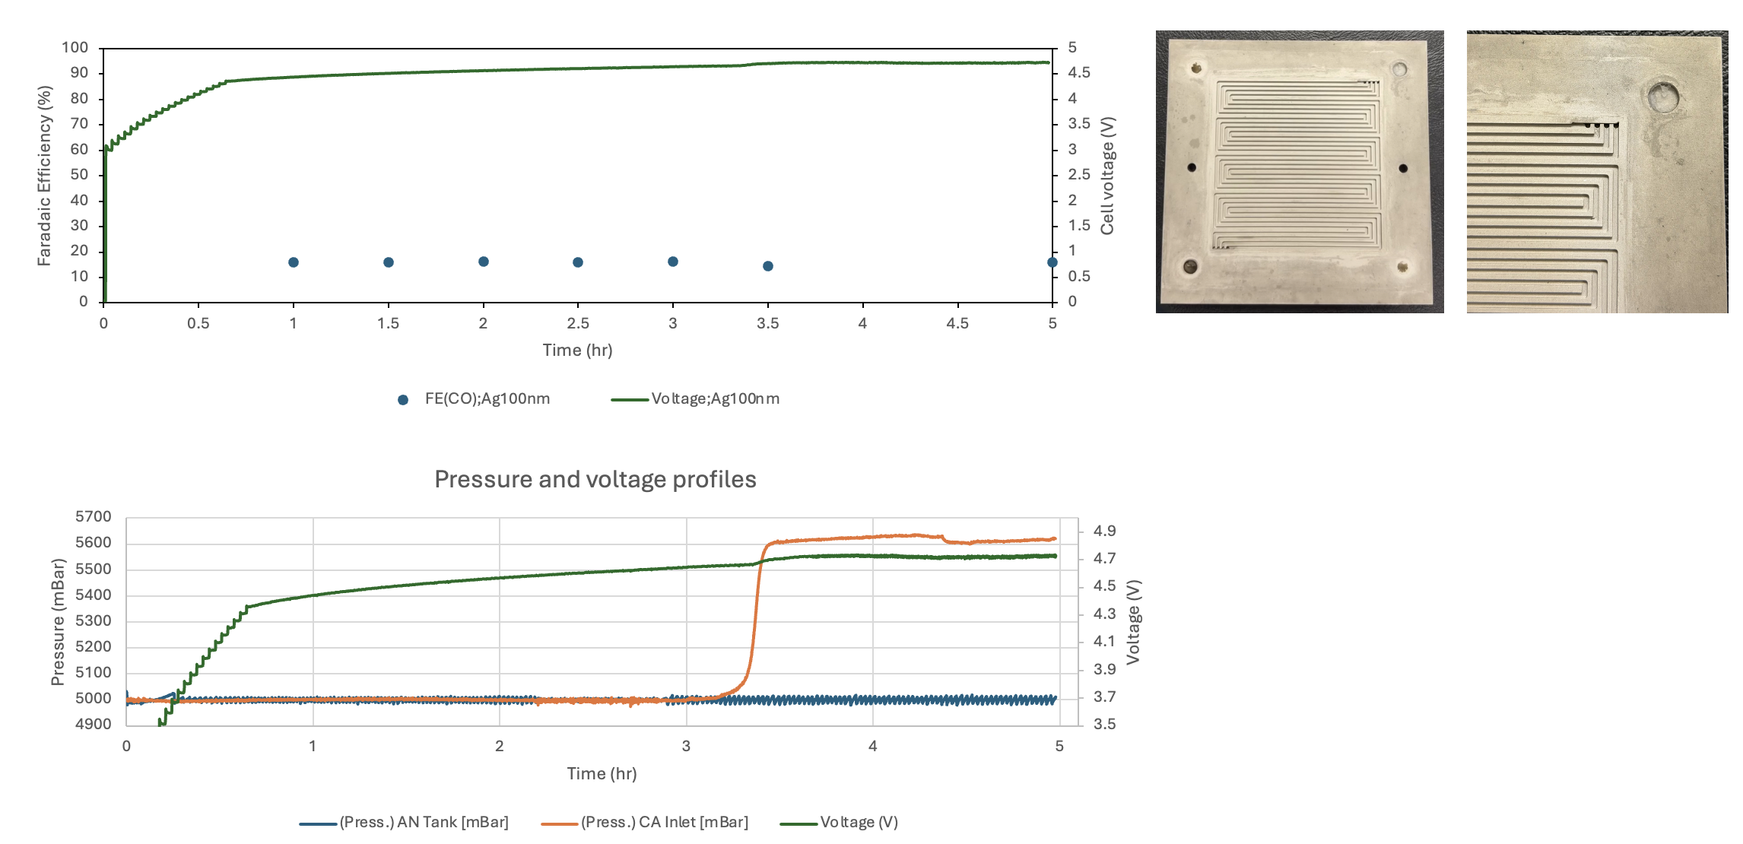
Figure 2. CO₂ electrolysis of Ag_{Sputtered} under 200ml/min CO₂, 150ml/min 0.25M KOH, 35°C, 5 BarG, and 200mA/cm²

Effect of Flow field configuration: Single vs Quad-serpentine
To ascertain the effect of flow-field channel configuration, the single and quadruaple serpentine cathodic flow-field channels were comparatively used, while the parallel flow-field channel was used for the anode side. The electrochemical reduction of CO₂ was experimentally conducted using a BPM system deployed 0.5NiSAC as a cathode under a humidified pure 200sccm CO₂ with 150ml/min of 0.25M KOH and IrO₂-TiPt anode at 100mA/cm². As shown in Figure 3, both the single- and quad-serpentine flow fields demonstrated identical results, sustaining FE(CO) > 90% for up to 7 h before complete cell failure occurred. This result further confirms that mechanical issues are not the primary cause of the operational failure within such a short period. Instead, the failure is more likely associated with the 0.5NiSAC cathode catalyst, whose hydrophobicity and chemical structure may differ from those of the previous batch.

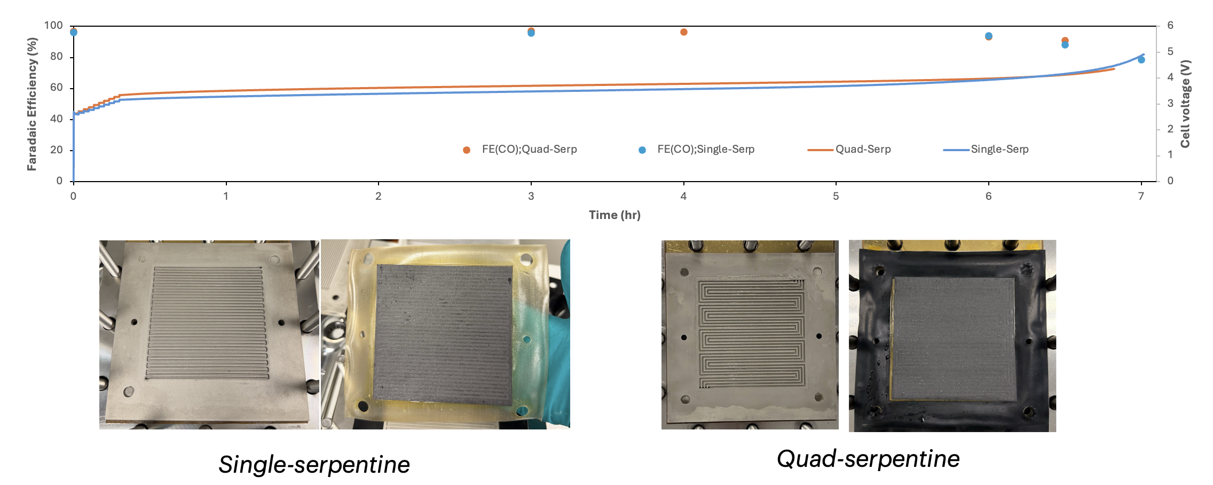
Figure 3. Comparison of single and quad-serpentine flow fields for CO₂ electrolysis of 0.5Ni-SAC in a 100cm² MEA electrolyzer under 200ml/min of CO₂, 100ml/min 0.25M KOH, and IrO₂-TiPt anode at 100mA/cm²

Upcoming tasks
- Characterization: XPS, Raman, cross-section SEM-EDX
- Catalyst synthesis:
  - T = 900C – 2hr
  - T = 800C – 3 & 4 hr
- 100cm² MEA electrolyzer – CO₂ electrolysis of as-prepared 0.5Ni-SAC in BPM system with 350µm/250µm silicone gaskets and 20 ft.lbs under a humidified 200ml/min CO₂, 150ml/min of 0.25M KOH, and IrO2-TiPt anode at 100mA/cm²
- Try 0.25Ni-SAC for 100cm2 BPM electrolyzer under 200ml/min CO2, 150ml/min 0.2M KOH, and 100mA/cm²
- Try AgSput300nm for 100cm2 AEM electrolyzer under 200ml/min CO2, 150ml/min 0.1M KHCO3, and 100mA/cm²

